YES! I would like to make a Donation!

MY DONATION AMOUNT IS:
$25 $1,000
$100 $5,000
$500 $10,000
I WOULD LIKE MY COMPANY TO BE ASSOCIATED WITH:
Military suicide awareness (#22ADAY)
Save a Warrior Challenge
Topeka Veterans Parade
Salute our HeroES GALA

Total: ____________
Name: ________________________________
Company Name: _________________________
Date: __________________________________
Signature: ______________________________
DETACH THIS PANEL AND SEND TO:
Military Veteran Project
PO BOX 3926
Topeka, KS 66604
*The Military Veteran Project is a 501(c)(3) nonprofit organization. Your contribution is tax-deductible to the extent allowed by law. No goods or services were provided in exchange for your generous financial donation.
Military Veteran Project Taxpayer ID# 46-0877378
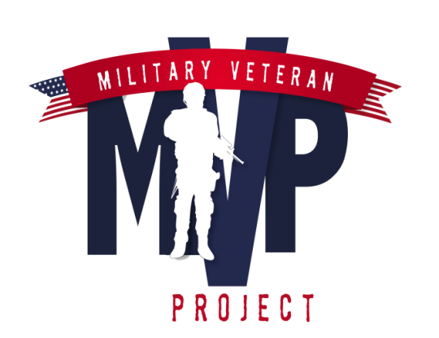

CONTACT US:
Military Veteran Project
PO BOX 3926 Topeka, KS 66604
(785) 633-2575
contact@militaryveteranproject.org

VISIT US AT:

www.facebook.com/militaryveteranproject
www.twitter.com/militaryvetera
www.instagram.militaryveteranproject
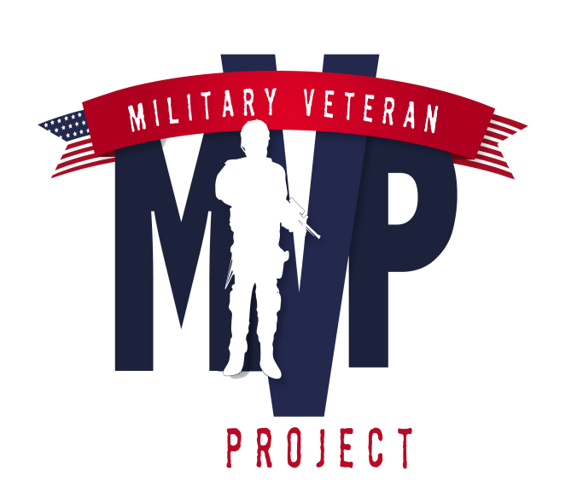
SPONSORSHIP OPPORTUNITIES

TREATMENT
RESEARCH
SUICIDE PREVENTION
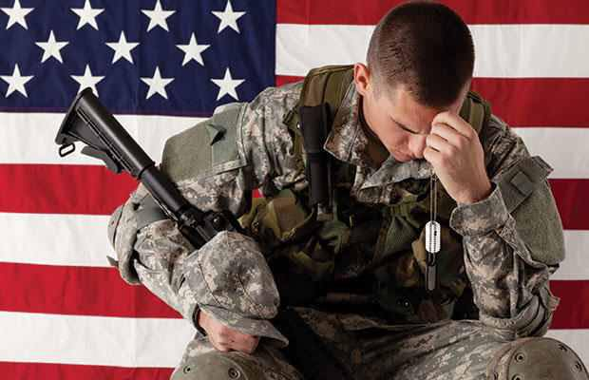
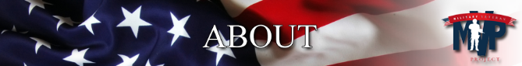

The Military Veteran Project is a volunteer-driven charity committed to funding the most promising research & treatment to help cure undiagnosed traumatic brain injury and post-traumatic stress for veterans. With research, treatment for post-traumatic stress disorder and by diagnosing untreated traumatic brain injuries, we know a difference can be made and lives can be saved.
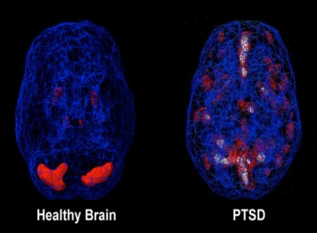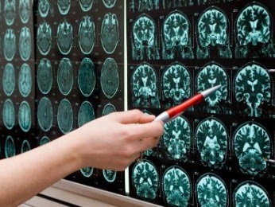
RESEARCH:
People often talk about the effects of Traumatic Brain Injury or the consequences of Post Traumatic Stress as separate conditions – which they are. But, for the person who is living with both TBI and PTSD, it can be hard to separate them because some of the symptoms can overlap. So why is it important to separate the two?
Even though these disorders may look the same from the outside, the treatment for each disorder can be drastically different…even opposing!
With proper research, the Military Veteran Project knows lives can be saved. We want to go to the root of the injury, internally in the brain, and then be able to direct veterans to proper treatment for either PTSD or TBI for overall success.

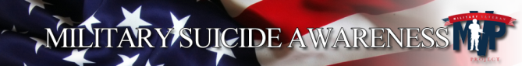
Every day, 22 veterans lose their battle to post-traumatic stress on American soil. That is 1 veteran every 65 minutes! It is time for us to take a stand by creating a Military Suicide Awareness (#22ADAY) in your community today.
Military Suicide Awareness is the advocacy action network of the Military Veteran Project for Suicide Prevention. Military Suicide Awareness is a natural next step to the mission of the Military Veteran Project. Awareness gives a voice to the vast network of volunteers, donors, and participants involved in the work of the Military Veteran Project.
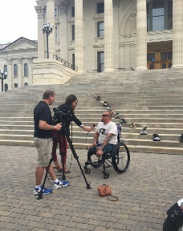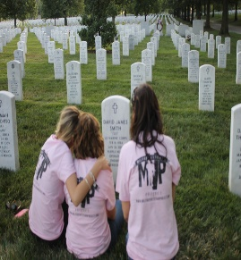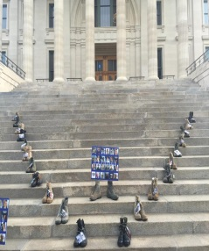
Events are organized by volunteers and are unique in every way – from small groups of people at local malls to hundreds uniting at local parks, schools and much more, in your hometown. We provide information and resources to help you become an advocate for Veterans and survivors.
Are you ready to create Military Suicide Awareness (#22ADAY) in your community? Register today to become an ambassador for Military Suicide Awareness at:
www.militaryveteranproject.org
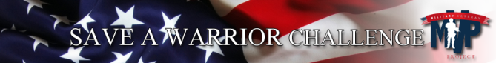
Every day, 22 veterans lose their battle to post-traumatic stress on American soil.
Help prevent another life being lost by participating in the SAVE A WARRIOR CHALLENGE for suicide prevention.
Unite your friends, family, schools, churches and local gyms to participate in the Save A Warrior Challenge. Once you are done with your exercises, take a 22 second moment of silence in their honor.
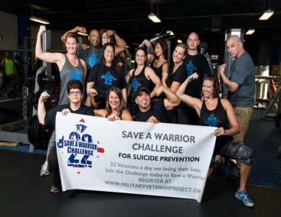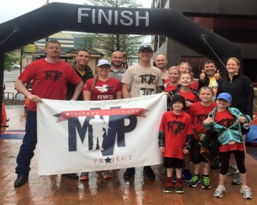
Register for free and order your SAVE A WARRIOR T-shirt today! The Military Veteran Project will give you the tools to raise funds online to share with your family and friends. Or register your gym and become an ambassador to start the monthly challenge.
Will you honor of the 22 veterans a day who have lost their battle? Are you ready to become an ambassador for SAVE A WARRIOR CHALLENGE? Register today at:
WWW.MILITARYVETERANPROJECT.ORG

