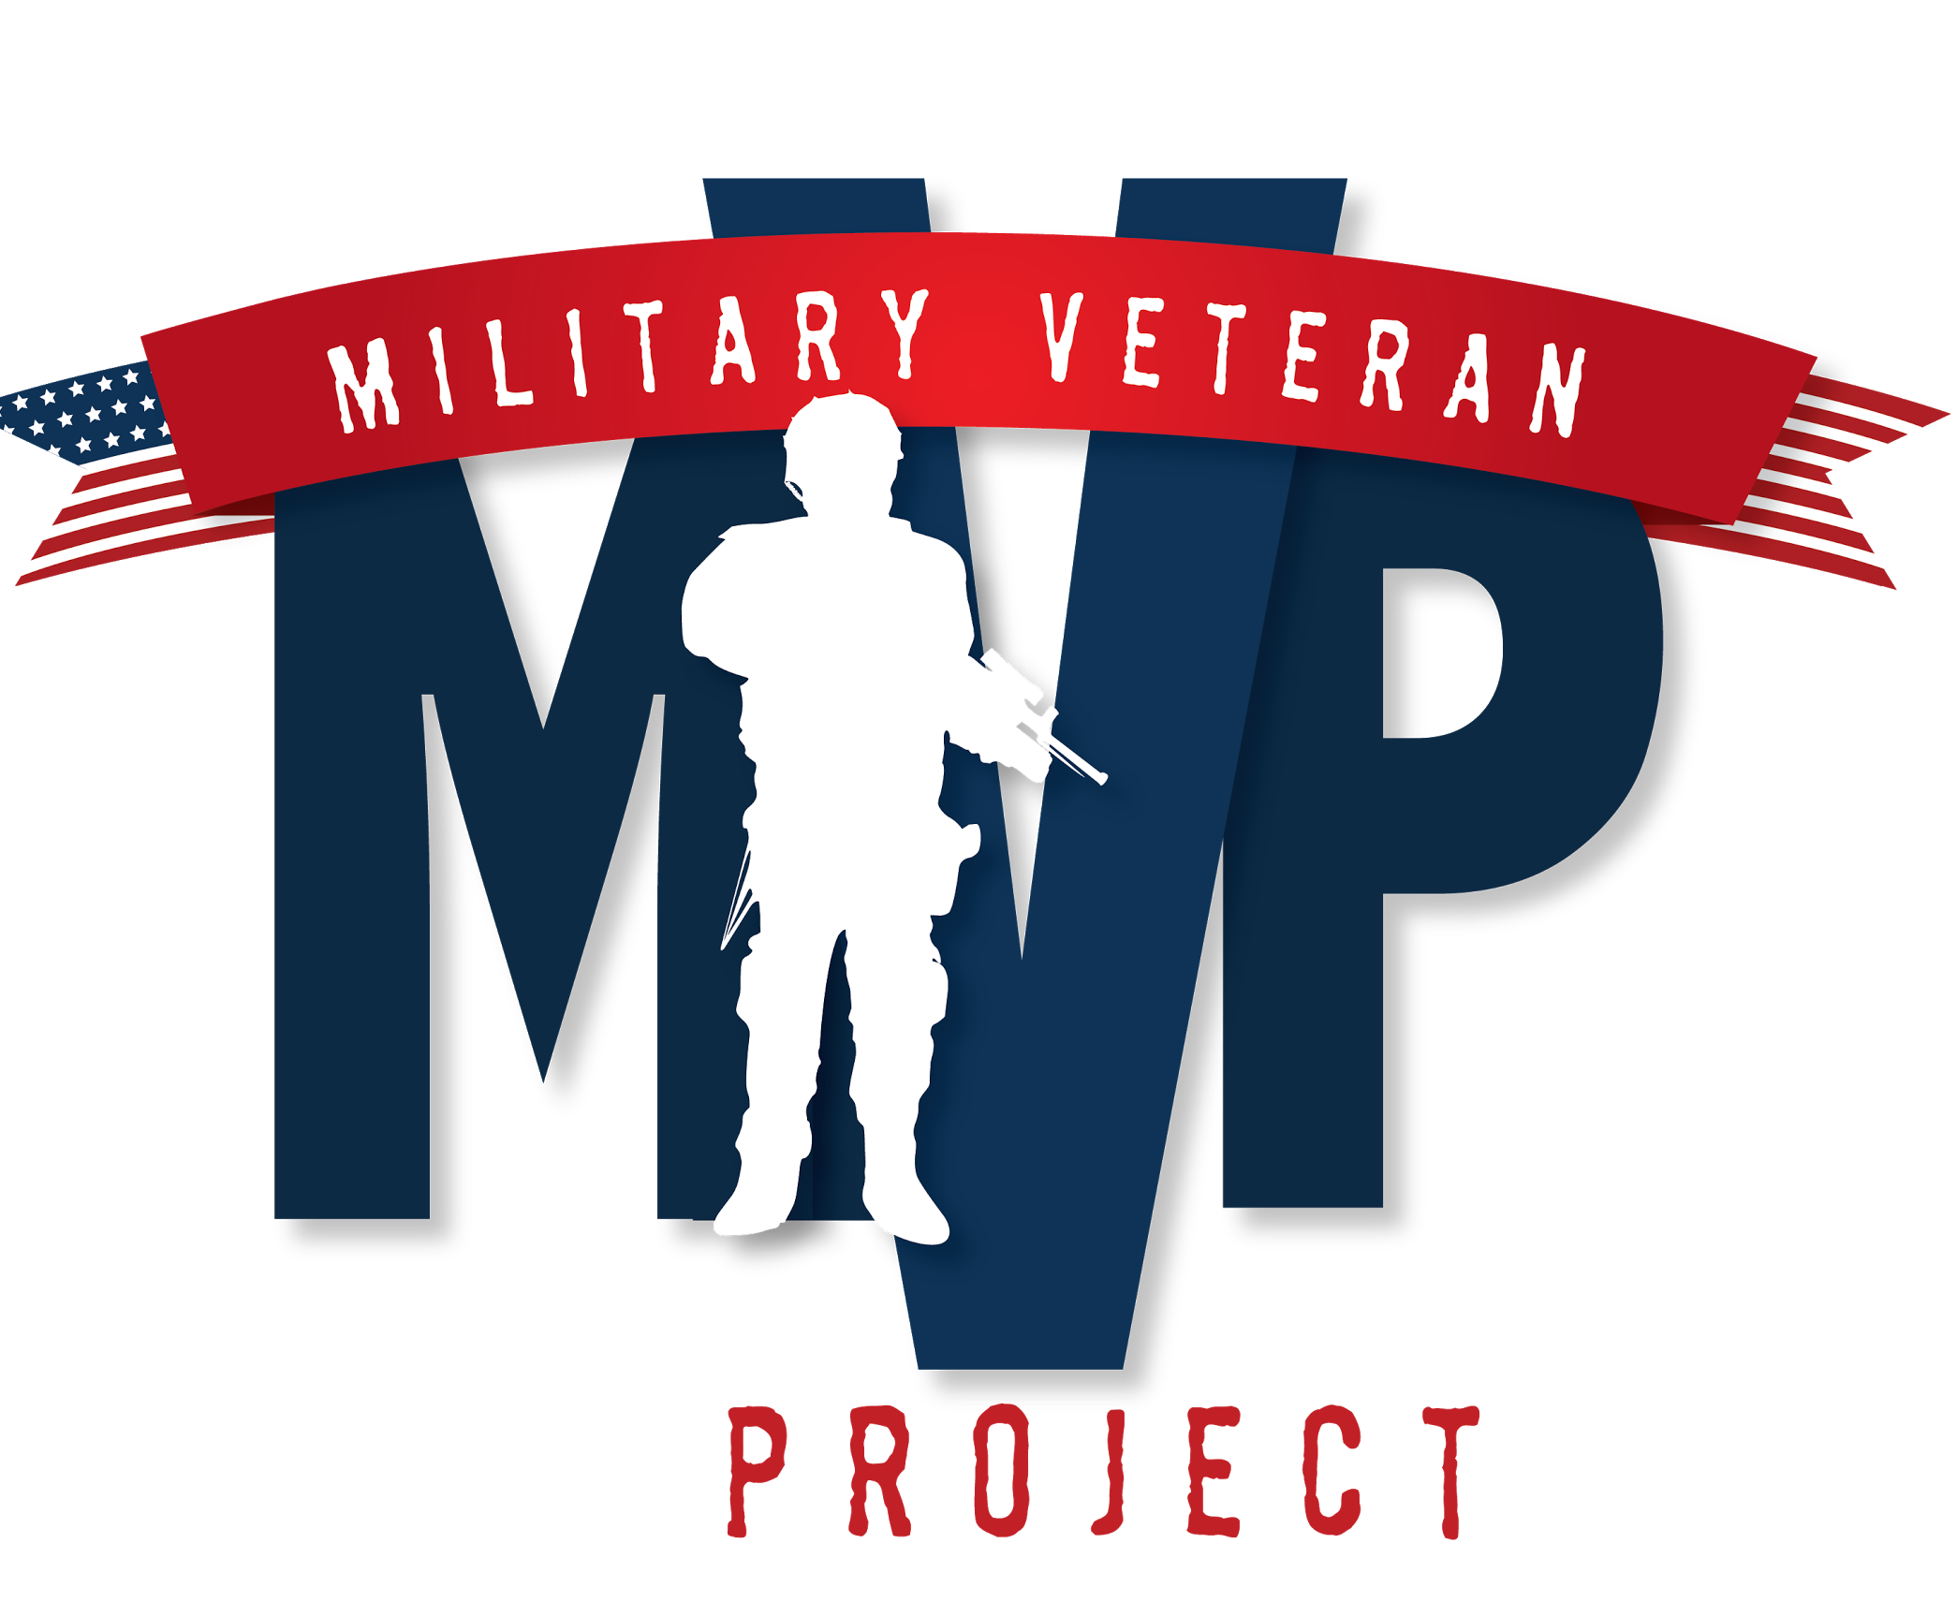

Dear Supporter,

For the last four years, the Military Veteran Project, has been uniting and supporting the Topeka and surrounding communities. Our goal is to establish a network of support and camaraderie among military veterans, families and the community in which they live, as well as to enrich bonds through philanthropy. In addition, MVP provides support to many local charities, corporations, locally owned businesses and government agencies including Veterans Administration and Department of Defense.
- Each February, we assist veterans at local Veterans Administration hospitals with community outreach and reintegration through volunteer opportunities in our community.
- Each month, we provide training and education to over a thousand volunteers worldwide for the Military Suicide Awareness #22ADAY advocacy action. Military Suicide Awareness gives a voice to the vast network of volunteers to raise awareness that each day men and women are coming home from war fighting a new battle on American soil.
- Each June, we give back to veterans in our local area by providing a day of service event. During this event, we pair businesses and veterans in need with one another for a day(s) of giving back.
- For the last four years, MVP has organized the Topeka Veterans Parade to honor those heroes who have selflessly served our community and country..

This year, we are pleased to be hosting the Freedom Festival of Topeka with the main event being the Topeka Veterans Parade to salute their service and celebrate our freedoms. We hope you will consider a sponsorship to allow us to continue to make a difference in the lives of military veterans and families in and around the community.

Profits from this year’s Freedom Festival will go directly to the mission of the Military Veteran Project of prevention of military suicide through research and treatment. An average of 20 veterans a day committed suicide in 2014, a trend that reflects record high rates among young men fresh out of the military and growing numbers of women taking their lives, the first actual count of suicides among former service members shows. The VA found the worst suicide pattern among male veterans, ages 18-29. Their suicide rate was 86 per 100,000 people, nearly four times the rate among active-duty service members last year. The Military Veteran Project has partnered with teams of medical researchers, health professionals, volunteers, donors, families and friends to help each veteran overcome obstacles to independence and reach his or her personal goals. We are pleased to lead the nation and our local Topeka community in military suicide prevention, which makes it possible for veterans to have opportunities to live and work in our community.

The Topeka Veterans Parade and Freedom Festival of Topeka will be held on Saturday, November 5 from 9:00 am- 2:00pm at the State Capital. It would be a privilege to include your company as a supporter of the Military Veteran Project. Please note the enclosed 2016 sponsorship form, which details our different sponsorship levels. A member of the Military Veteran Project will contact you within the next few weeks to discuss a possible sponsorship. If you have questions or need additional information before then, please contact our sponsorship chair
Sincerely,

Melissa D. Jarboe
Founder & CEO
Military Veteran Project
Melissa@militaryveteranproject.org
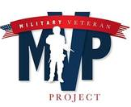
Sponsorship Form
Contact Information

Name:_________________________________________Title:_____________________________________________
Business Name/Organization:________________________________________________________________________
Mailing Address: _________________________________________________________________________________
City: _________________________________________________ State: ______________ Zip Code: _____________
Phone: ______________________ Fax: _____________________ E-mail:____________________________________
Sponsorship Levels

Medal of Honor - $1,000 _____________
- Exclusive marketing of your choice (sponsoring national anthem, award ceremony, etc.)
- Company banner displayed at Freedom Festival of Topeka
- Promotional announcements/advertising over loud speakers during the event
- Prominent recognition in event advertising
- Company logo on t-shirts
  - Sponsorship funds must be received by 5:00 pm Friday, 10/14/2016 to appear on shirt
- Option for promotional material at the event and in participants’ bags
- Company logo on Freedom Festival of Topeka banner
- Recognition on Facebook

Bronze Star- $500 ____________
- Company banner displayed at the Freedom Festival of Topeka event
- Promotional announcements/advertising over loud speakers during the event
- Prominent recognition in event advertising
- Company name on t-shirts
  - Sponsorship funds must be received by 5:00 pm Friday, 10/14/2016 to appear on shirt
- Option for promotional material at the event and in participants’ bags
- Company name on Freedom Festival of Topeka banner
- Recognition on Facebook

Purple Heart - $250 ____________
- Promotional announcements/advertising over loud speakers during the event
- Option for promotional material at the event and in participants’ bags
- Company name on Freedom Festival of Topeka banner
- Recognition on Facebook

Total $______________

Please make checks payable to: Military Veteran Project
Mail to: Military Veteran Project, PO Box 3926, Topeka, KS 66604

